Henry Okamoto’s Mark Recapture Data

From October 1989 to November 1994, State of Hawaii DAR employee Henry Okamoto tagged 4,179 individuals of *Pristipomoides filamentosus*.

Removed data from any fish that was not an Opakapaka

Removed fish that did not have a tag ID associated

This gets us to Okamoto’s reported 4179 number, but does not account for fish with concerning comments (‘died’).

Removal of any questionable sizes (those with characters such as ‘?’ or ‘*’ after the FL)

Created a table with each fish’s time at liberty, FL (in inches) when the fish was marked, and FL when the fish was recaptured. For fish with multiple recaptures, multiple entries were added to the table. For instance, a fish that was recaptured twice had an entry for:

initial marking and first recapture

first recapture to second recapture

initial marking to second recapture

n = 487!

Faben’s model for fitting a VBGF using non-linear least squares methods for fitting a linear model.

Linf = maximum recapture size in data set

K = 0.31 # found in some old code and used,

t.0 = 0.

Faben’s method produced a model with a K estimate of 0.23467 and a Linf estimate of 66.19582

Residuals fit appeared evenly distributed about the mean with increasing deviation for larger fitted values

Previously reported growth curve parameter estimates are summarized in Andrews et al 2012.

Unsure about the sample sizes of other studies

- Ralston and Miyamoto – 6 samples

- Andrews et al - 64 samples used by

* Demartini Et al 1994 – 92 specimines
* Uchiyama and Tagami – Not reported
* Moffit and Parrish – 1996 – “about 100”
* Ralston and Williams 1998 – 285 (Marianas)
* 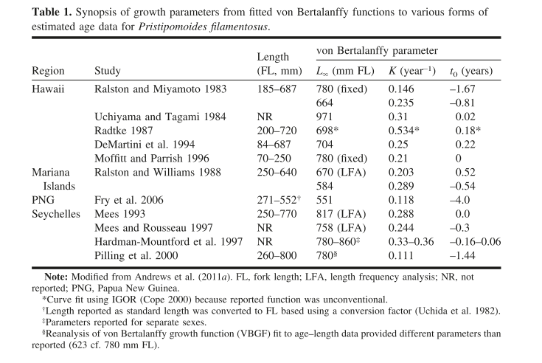

Results using Faben’s method

# K estimate = 0.23467

# l.inf estimate = 66.19582

To Do: Wang methods